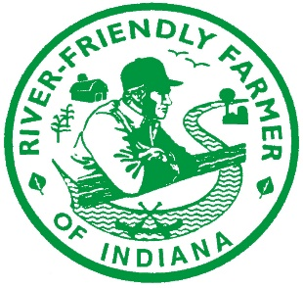
2023 RIVER FRIENDLY FARMER PROGRAM NOMINATION FORM guidelines
Nominations for the River Friendly Farmer (RFF) Award are now submitted online. This hardcopy nomination form is provided for ease of completing the online form OR for interviewing your nominee. This form is provided for you to view and answer the questions before actually submitting the nomination form online at: https://bit.ly/River-Friendly2023.
The River Friendly Farmer Award is given annually to producers whose best farm management practices protect Indiana’s soil and water resources. Since 2000, the River Friendly Farmer Award has been given to over 1,000 Indiana farms.
The opportunity to nominate someone is available to all Soil and Water Conservation Districts and watershed organizations. The nomination provides the means to document a farmer nominee's commitment to protecting and enhancing the water quality of Indiana’s lakes, rivers and streams. Each SWCD can submit up to TWO nominees. Watershed organizations wishing to submit a nominee must submit the request to the appropriate Indiana County SWCD for consideration on their nominee.
Complete all information, where applicable, in each of the categories below. Applications are due by close of business on Thursday, June 8, 2023.
The RFF program is a collaborative effort of government agencies, agricultural organizations, Indiana Soil and Water Conservation Districts (SWCDs) and farmers whose goals are to improve soil and water quality and restore and sustain human and wildlife habitat in Indiana’s watersheds.
The program is sponsored by the:
• Indiana Association of Soil and Water Conservation Districts (IASWCD) and our 92 SWCDs
• Indiana Farm Bureau, Inc.
• Indiana State Department of Agriculture, Division of Soil Conservation
• Purdue Cooperative Extension Service
• USDA Natural Resources Conservation Service
Every River Friendly Farmer Award Recipient receives*:
- An Engraved Blue Ribbon
- An RFF Award Certificate
- An RFF Sign (2’x3’ double-sided aluminum sign, given Jan-March 2024)
- An RFF shirt and hat
- Recognition at the Award Ceremony in August at the Indiana State Fairgrounds
- Two state fair admission tickets to those attending the Award Ceremony
*(Please note that some years these supplies are difficult to acquire and may vary.)

2023 RIVER FRIENDLY FARMER NOMINATION GUIDE
Note: This form is provided as a guide ONLY. Please use this guide to view the questions and then fill out the online nomination form.
Nominations accepted via the online form only.

QUESTIONS ON THE ONLINE FORM

CONTACT INFORMATION FOR THE SWCD AND/OR WATERSHED ORGANIZATION NOMINATING THIS PRODUCER
Note: We may need to rely on the nominator to communicate with the farmer nominated, especially if email is not available or checked regularly. Please fill out this section with the information needed for us to contact YOU (not the farmer's information in this section).
Name of SWCD or watershed organization that is nominating the producer:
________________________________________________________________________________
Contact PERSON at the nominating SWCD (first and last name here):
________________________________________________________________________________
PHONE NUMBER of the nominating SWCD:
________________________________________________________________________________
EMAIL ADDRESS of the nominating SWCD or watershed organization:
________________________________________________________________________________
CONTACT INFORMATION FOR NOMINEE
This section is information needed regarding the Person/Farmer/Farm
that is being nominated for this award.

County the farm is located in:
________________________________________________________________________________
Nominee's First Name:
________________________________________________________________________________
Nominee's Last Name:
________________________________________________________________________________
Nominee's Street/Road (mailing address):
________________________________________________________________________________
City/Town, State and Zip Code:
________________________________________________________________________________
Daytime phone # where nominee can be reached:
________________________________________________________________________________

Email Address for Nominee:
(Note: If farmer does not have email or check it regularly, please type in email address of SWCD nominating this farmer. Email is the PRIMARY way that information will be communicated.)

________________________________________________________________________________
If Nominee is accepted, what is the appropriate name/title for the Award Certificate? (i.e. John and Jane Doe OR Acme Farms, Inc.). PLEASE verify spelling as this will print on the awards certificate as stated here:
________________________________________________________________________________
FARM INFORMATION
Farm Address:
(Note: If the Farm address is the same as nominee address already listed, please skip down to Farm Name.*)
________________________________________________________________________________
If the Farm address is different than the address listed above. (Please answer farm information questions below regarding ADDRESS.)
Farm Street/Road Address: __________________________________________________________
City/Town, State and Zip Code: _______________________________________________________

*Farm Name (if applicable):
________________________________________________________________________________

What Watershed(s) is your farm located in?
(Note: Not sure about the watershed? Please contact an IDEM Watershed Specialist at http://www.in.gov/idem/nps/2359.htm)

________________________________________________________________________________

What does your farm produce?
(In this section, briefly describe your farming operation (i.e. strictly grain, grain/livestock, specialty, aquaculture, fruits/vegetables, trees, etc.)
________________________________________________________________________________
________________________________________________________________________________

What rivers, streams, and/or ditches run through your farm?
Please name only the major ones.
________________________________________________________________________________
What conservation cropping systems or practices do you use?
Note: A sustainable cropping system is a management strategy that protects our natural resources and actually improves the soil.
________________________________________________________________________________
________________________________________________________________________________
WHY are conservation practices important to your operation? (i.e. How have conservation practices positively impacted your soil's health, farm economics, wildlife, pollinators, etc.?)
________________________________________________________________________________
________________________________________________________________________________
Specifically, how have your conservation practices improved the quality of water that leaves your farm?
________________________________________________________________________________
________________________________________________________________________________
What other conservation management practices do you use? (i.e. maintaining a wetland or woodland; providing wildlife habitat, etc.)
________________________________________________________________________________
________________________________________________________________________________

If you own a livestock operation, what conservation management practices do you use? Please also describe your nutrient management program.
For example: How do you manage your operation in a way that is environmentally sound, and what BMP's do you use?
________________________________________________________________________________
______________________________________________________________________________
________________________________________________________________________________

How do you share your commitment to conservation with your community? (i.e. list your involvement with your local SWCD, 4-H, FFA, Farm Bureau, county government, school volunteer, church, conservation organizations, educational field days)
________________________________________________________________________________
________________________________________________________________________________

Any additional information you would like to share (i.e. farm/family history; other conservation awards received, etc.)
________________________________________________________________________________
________________________________________________________________________________
________________________________________________________________________________
If you could share one piece of advice with a new farmer or one who is hesitate to try a conservation practice, like cover crops or no-till, what would that advice be?
________________________________________________________________________________
________________________________________________________________________________
________________________________________________________________________________

ADDITONAL INFORMATION

SIGNATURE PAGE - required
A signature page is a required separate document that can be obtained from the IASWCD website and either mailed or emailed to IASWCD.
Three original signatures are required to complete the 2023 River Friendly Farmer application (one signature each from the nominee, an SWCD staff person, and a technical representative). The signature page must be completed and emailed to Amy Work at: amy-work@iaswcd.org or mailed to IASWCD at 225 S. East St, Ste. 142, Indianapolis, IN 46202 by June 8, 2023. See additional details on the page itself. Applications are not complete until the signature page is received.

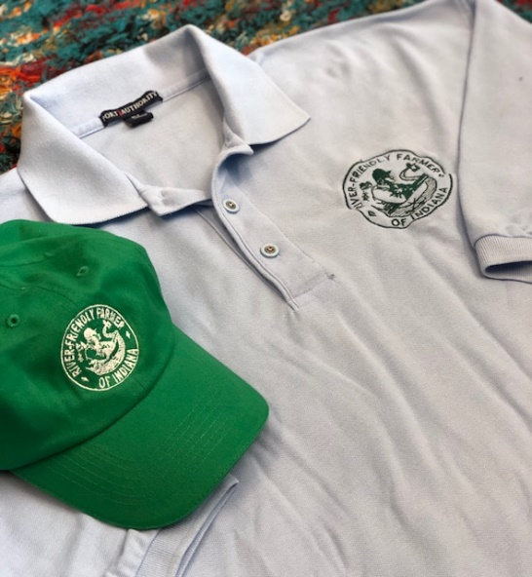
RFF APPAREL
River Friendly Farmer Award recipients receive one complimentary polo shirt and hat (per application) with the RFF logo.
Please indicate your preferred shirt size on the online form. (Note: T=tall size). ONLY ONE SHIRT IS COMPLIMENTARY. (Additional shirts may be ordered later when responding for attendance at the awards event.)
Men’s: Small Medium Large Large-T XL XLT 2XL 3XL
Women’s: Small Medium Large XL 2XL 3XL
NOTE: Details regarding ordering ADDITIONAL shirts and hats will be forthcoming in award letters sent out mid-June.

TIMELINE

DEADLINE
The completed ONLINE nomination form must be submitted electronically to the Indiana Association of Soil and Water Conservation Districts by a county Soil and Water Conservation District (SWCD). Each SWCD may submit up to two River Friendly Farmer applications for 2023. The deadline for submission is end-of-business on June 8, 2023. If you have any questions, contact Amy Work at 317.692.7374
or amy-work@iaswcd.org.
LINKS TO RFF FORMS
Online RFF Submission Form
Signature Page (Word doc version)
Signature Page (pdf version)

