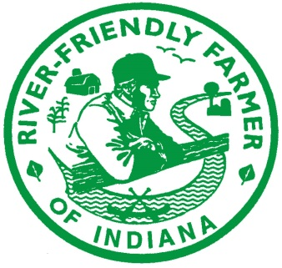
River Friendly Farmer Signature Page
To be submitted to the IASWCD by June 5, 2026
Three Signatures required (see explanation below)

Applicant/Farmer Name: ___________________________________
County: ____________________________

This page or a copy of this page must be mailed or emailed to IASWCD. (Mailing address: IASWCD, 225 S. East St., Suite #142, Indianapolis, IN, 46202 or email to: amy-work@iaswcd.org).

Your River Friendly Farmer application is not complete until the signature page has been received. Applications (submitted online) and signature pages should be received by IASWCD no later than
June 5, 2026.

Farmer Nominee/Applicant Signature*: _____________________________________________________Date: ______________________
SWCD Representative Signature**: _____________________________________________________Date: ______________________
Technical Representative Signature***: _____________________________________________________Date: ______________________
Explanation of the three required signatures:

*Farmer nominee for the 2026 River Friendly Farmer Award: The nominee’s signature certifies the nominee acknowledges that he/she verifies the information in the application to be true. This signature indicates that the nominee is not currently under review by a state or federal agency for an environmental violation of any kind. Nominee further understands that photographs will be taken at the award ceremony and nominee is granting permission for use of these photos to IASWCD for their website, social media and possibly other publications.

**SWCD representative: District staff person who completed the onsite farm review prior to submitting the application.

***Technical representative: USDA NRCS District Conservationist, Purdue CES Extension Educator, Indiana State Department of Agriculture Division of Soil Conservation Resource Specialist, or SWCD technical representative who has reviewed the application and certifies the conservation practices outlined in the application are acceptable BMPs.


IASWCD
River Friendly Farmer
225 S. East Street, Suite 142
Indianapolis, IN 46202
Ph. 317.692.7374
www.iaswcd.org
Questions: Amy Work at amy-work@iaswcd.org

